Primary Care Physician In-Service on Aboriginal Homelessness

http://infocusconsulting.ca/aboriginal-homelessness-resources/pcpiah/

Shortened Link: bit.ly/2n7CstO

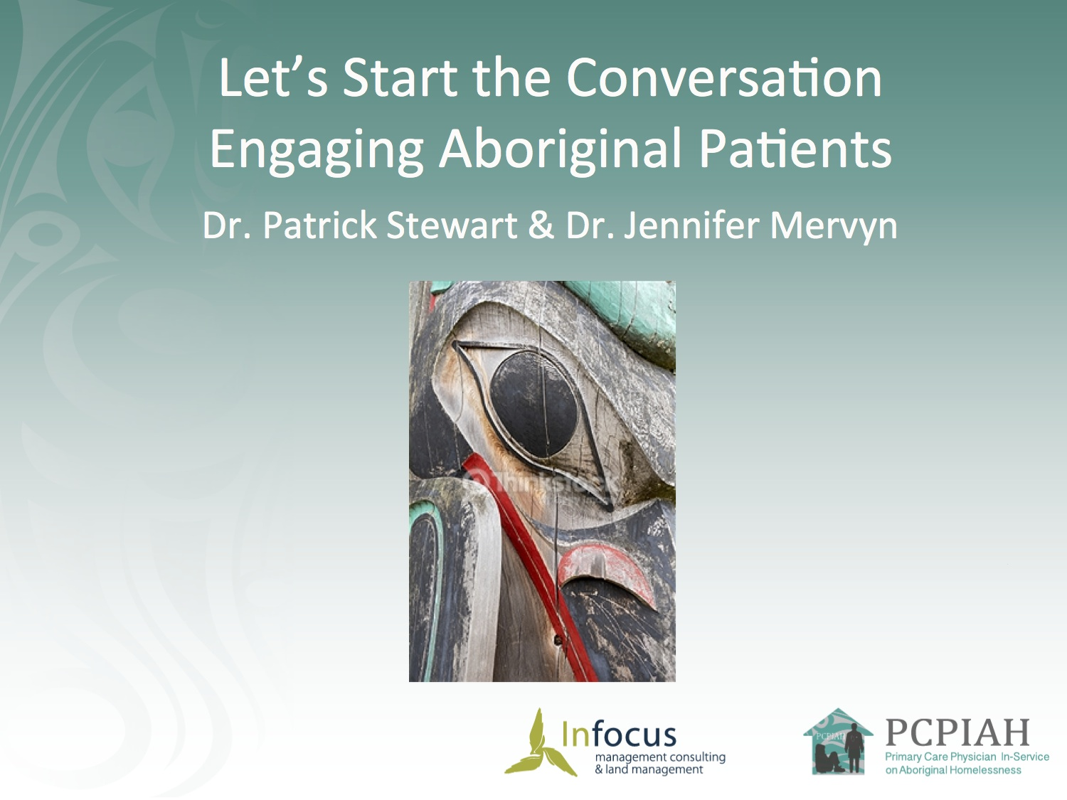
Let’s Start the Conversation
Engaging Aboriginal Patients
Dr. Patrick Stewart & Dr. Jennifer Mervyn

Internal link: http://bit.ly/AboriginalHospitals
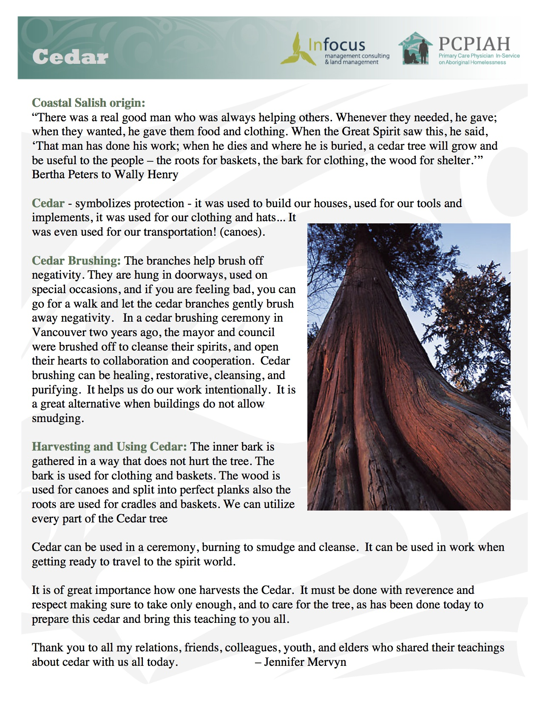
Cedar

Symbolizes protection - it was used to build our houses, used for our tools and implements, it was used for our clothing and hats... It was even used for our transportation! (canoes).

Cedar can be used in a ceremony, burning to smudge and cleanse. It can be used in work when getting ready to travel to the spirit world.

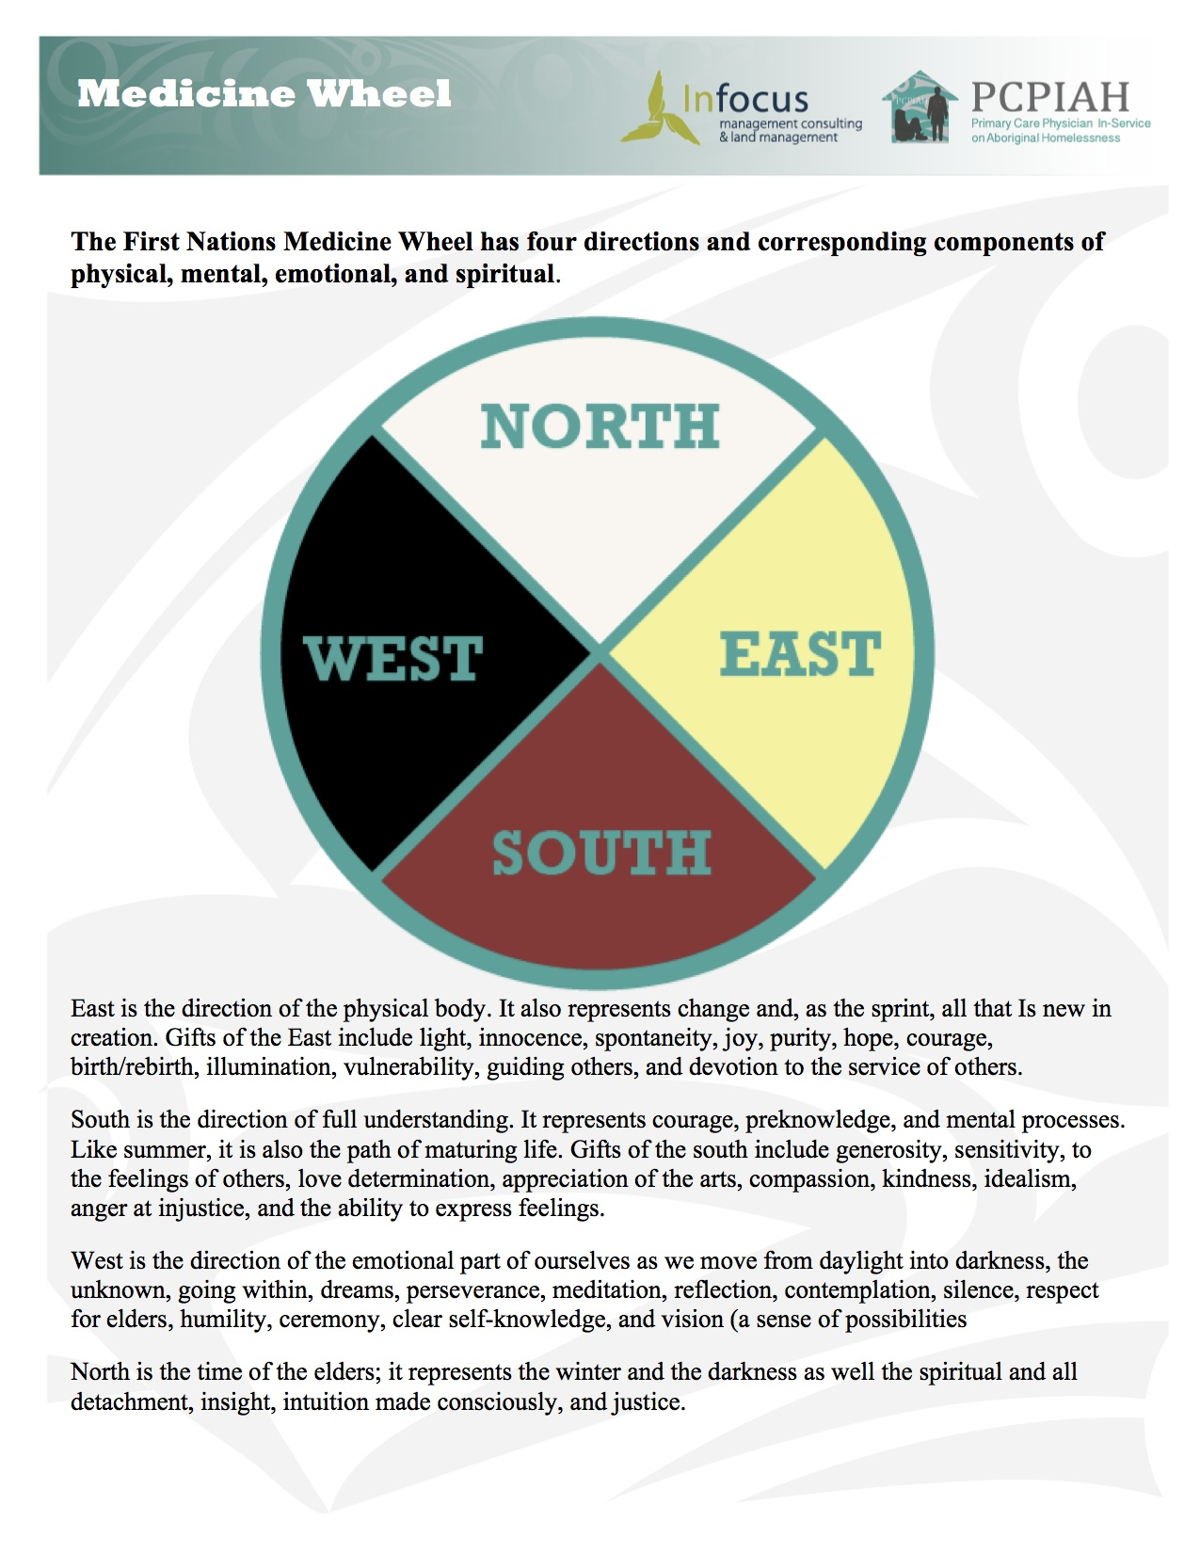
The Medicine Wheel

The First Nations Medicine Wheel has four directions and corresponding components of physical, mental, emotional, and spiritual.

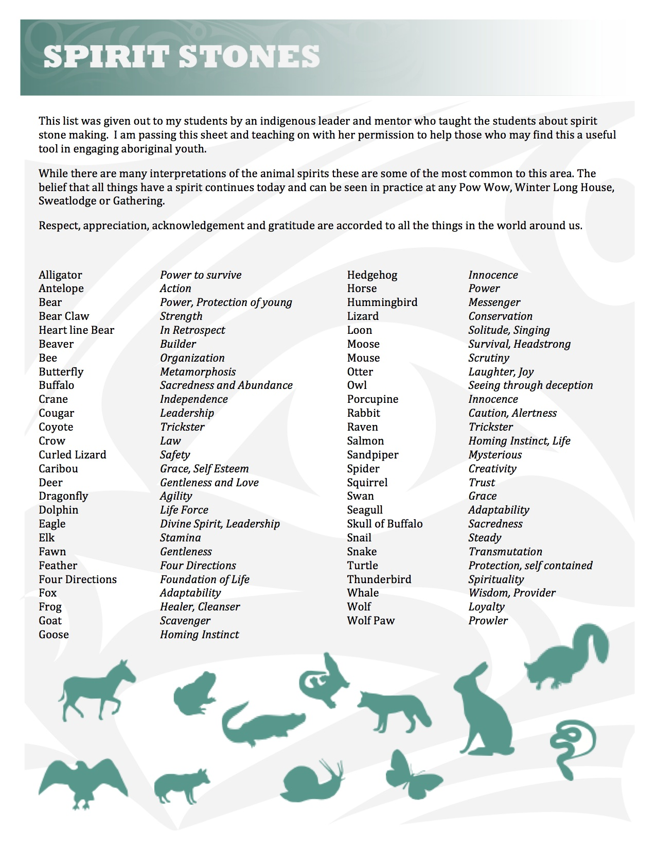
Spirit Stones

While there are many interpretations of the animal spirits these are some of the most common to this area. The belief that all things have a spirit continues today and can be seen in practice at any Pow Wow, Winter Long House, Sweatlodge or Gathering.

Respect, appreciation, acknowledgement and gratitude are accorded to all the things in the world around us.

